Chapter 10: Transformation and congruence
Name: _____________________________
1 Reflect these shapes in the line AB.
a | 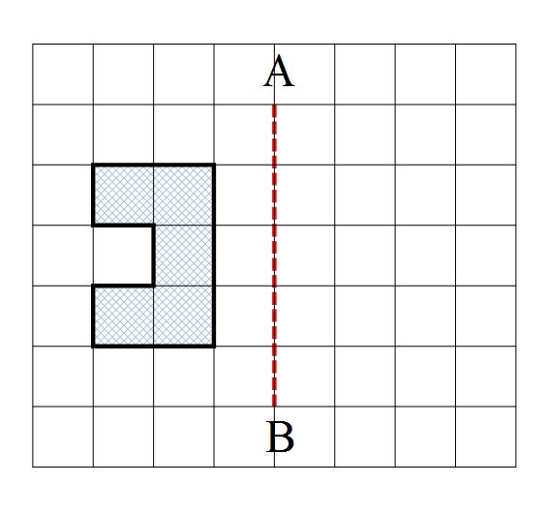 | b | 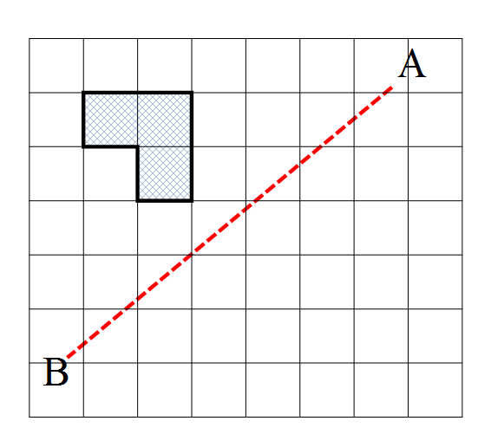
c | 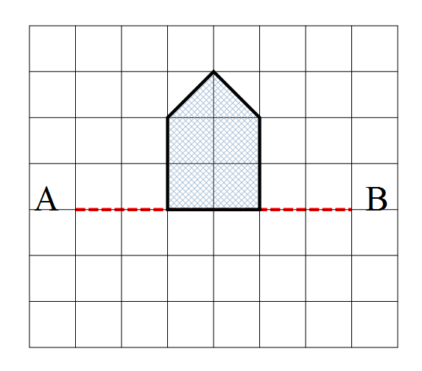 | d | 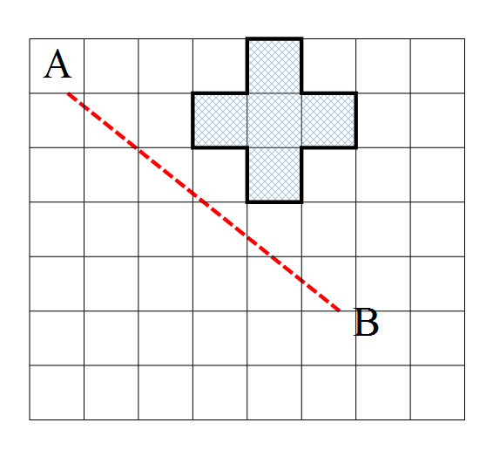
2 Translate each shape by following the instructions.
a | 3 units to the right | b | 2 units down
 | 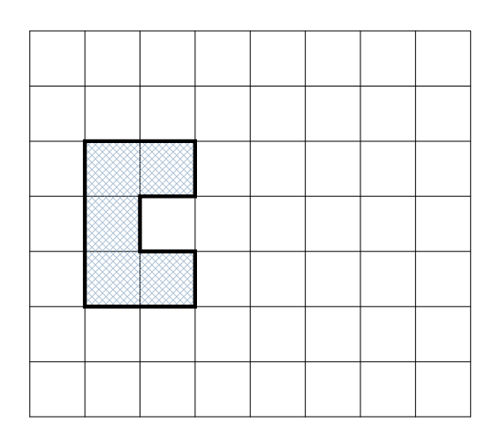 |  | 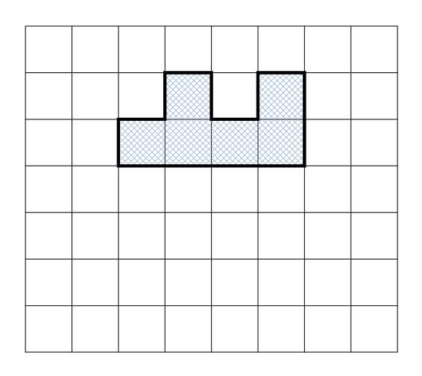
c | 4 units right then 2 units down | d | 3 units up then 4 units left
 | 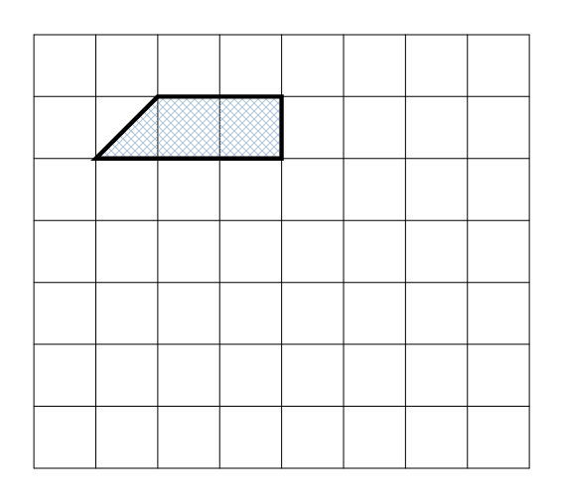 |  | 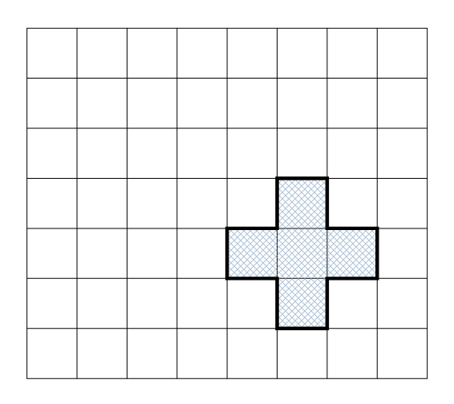

3 Rotate each shape as indicated.
a | 90° clockwise around X | b | 180° clockwise around X
 | 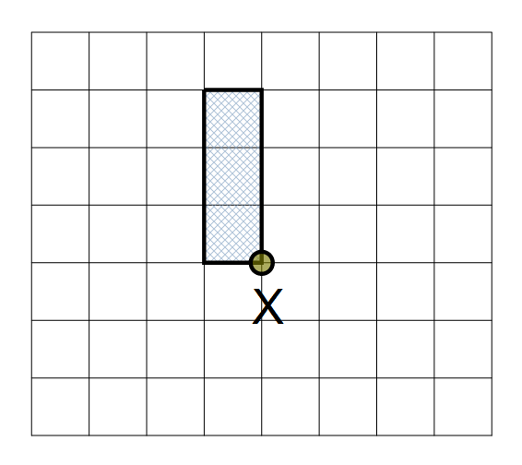 |  | 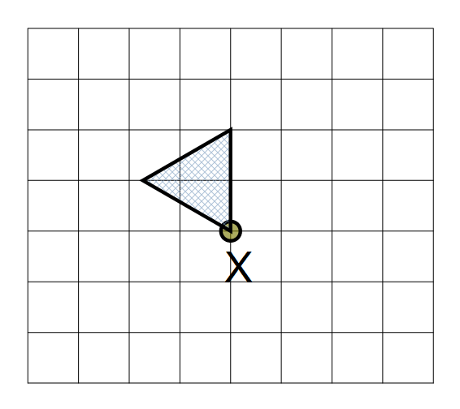
c | 90° anticlockwise around X | d | 45° clockwise around X
 | 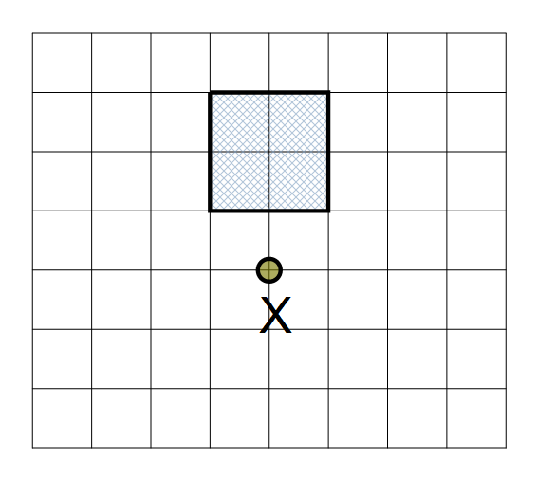 |  | 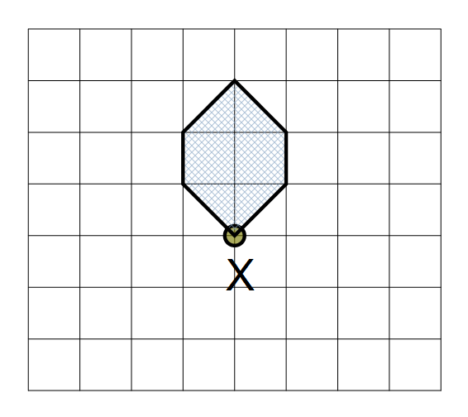

4 For this question, you may want to use the grid provided below to help you.

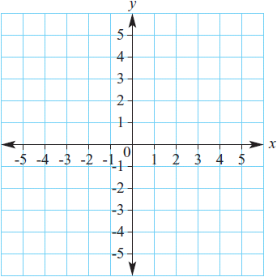
a Give the coordinates of the image of the point A(2, 1) after it is translated by these vectors:

i (1, −3)

___________________

ii (−4, 2)

___________________

5. Which of the test (SSS, SAS, AAS or RHS) would you choose to test the congruence of these pairs of triangles?
a b
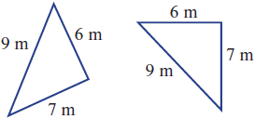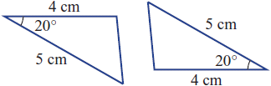

6 These pairs of triangles are congruent. Find the values of the pronumerals.
a b
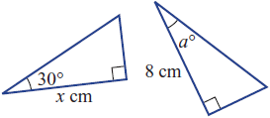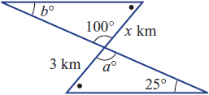

7 Decide, with reasons, why these pairs of triangles are similar. State which of the four tests AAA, SSS, SAS or RHS applies.

a b 